**Assignment 1**

Problem Statement

Set up/Install the database sakila. The database will be used for next MySQL Assignments as

well. Refer the Links given above for help in setting up the database.

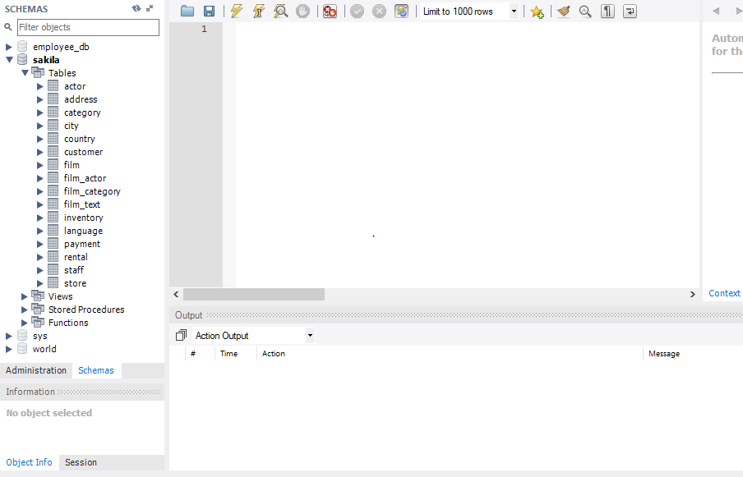

Sakila Database has been installed in MySQL.